Implementing Forms Security for Web Sites

In these exercise, we will start by looking at a few approaches to applying security to your web applications.

It is worth pointing out why we have left security till the very end.

1. It is a pain as a developer to have to log in to our system every time we want to do something. It is a very effective way of slowing down the development process.

2. It is better to focus on the hard bit of writing a system. I have seen many systems over the years that consist of a login screen and nothing else.

What is Security?

There are three issues that we need to consider these are

- Authentication

Who wants to use the system?
Is it really them?

- Authorisation

What actions is this person allowed to perform on the system?
Can they only use the bits they have permission to use?

- Secure Communication

Are other people able to intercept the data and eavesdrop on the communication?

Authentication in .NET

When we are talking about authentication we are typically talking about login systems for our applications.

In .NET, there are potentially three systems of authentication.

- Windows
- Forms
- DIY

Windows authorisation makes use of the users and groups set up on the Windows machine that the web application is running from. This means that to create additional users it must be handled by the administrator for that machine. For a desktop application, this would be fine however for a web application this is less helpful. In the case of many web applications there is typically a web page allowing them to sign up for a new account, e.g...

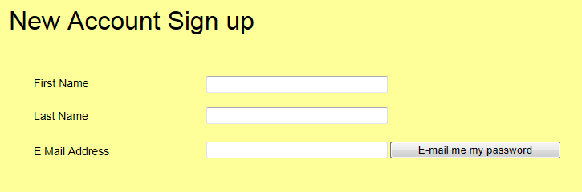

Windows authentication is not best suited to this feature of allowing users to create their own accounts.

Forms Authentication

Forms security involves applying what is called a framework.

In developing applications, there are certain tasks that we end up creating all the time.

One good example of this is security.

To have to re-invent the wheel every time we need security is a waste of time and effort.

By using a framework, we simply take an existing set of tools “off the shelf” plug them into our application and then tweak the code such that it is suitable for our needs.

Creating the Security Framework

So far in the module when creating our web sites, we have opted for creating empty sites.

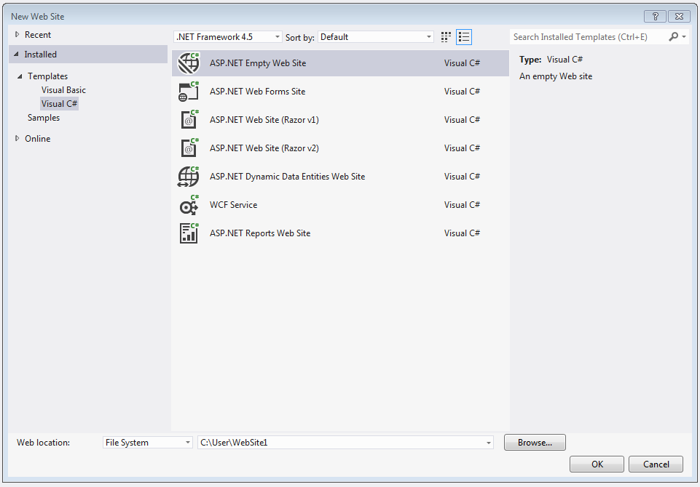

The big advantage of taking this approach is that it puts us in control of our code. If we let Visual Studio create a web forms site

It creates a whole load of code automatically much of which will be a mystery to us how it works.

If we take the second option the security is add to the site for us however we will not understand how it works, also there will be other features that may be redundant in our specific system.

To continue with this work, you will need to download Address Book finished from the module web site.

Web.config

One much neglected but important file in a .NET web site is the Web.Config file. This file is an XML file that contains configuration settings for the current web application.

The Web.Config file is in the solution explorer...

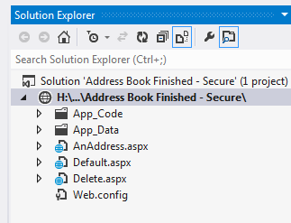

Web config (as the name suggests) allows us to control features of this web site’s configuration.

When you first open the file, you will see something like this…

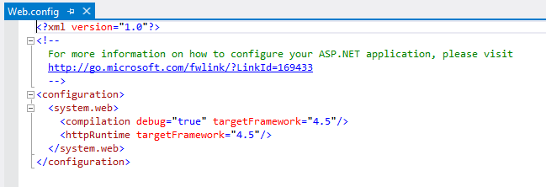

We are going to make two changes to the file.

- Activate the Forms security framework.
- Make sure that Visual Studio uses the correct database engine

Activating Forms Security

The first step is to modify Web.config to activate forms security for this web application like so…

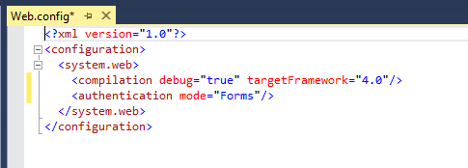

Setting the Database Engine

Modify the web config like so…

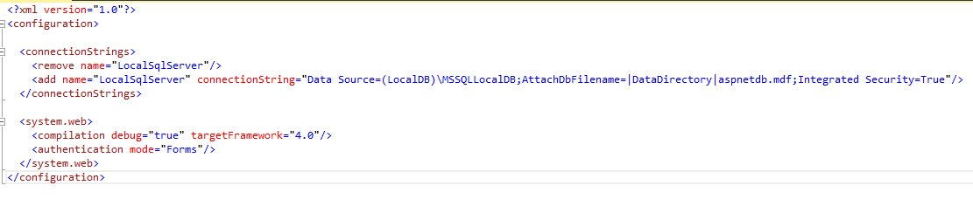
Here is the code so that you may copy and paste it…

<connectionStrings>
<remove name="LocalSqlServer"/>
<add name="LocalSqlServer" connectionString="Data Source=(LocalDB)\MSSQLLocalDB;AttachDbFilename=|DataDirectory|aspnetdb.mdf;Integrated Security=True"/>
</connectionStrings>

Save and close the Web.config file.

Now that we have done this we need to create a secure area in the application.

Right click on the web site and select new folder....

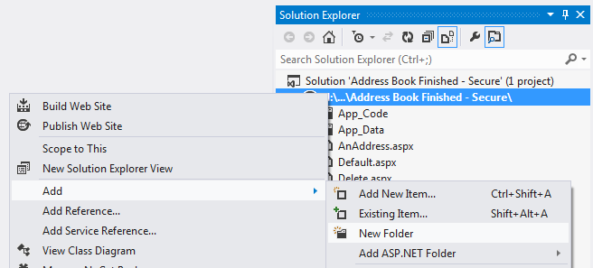

Name the new folder “Secure”.

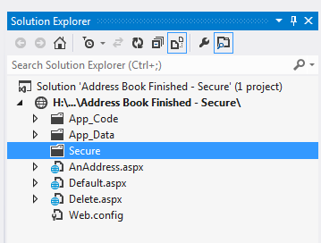

Next, we want to move all the web forms into this secure folder.

To do this click on each web form while holding down the CTRL key.

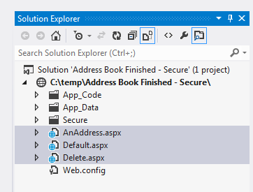

Now right click on the files and cut them.

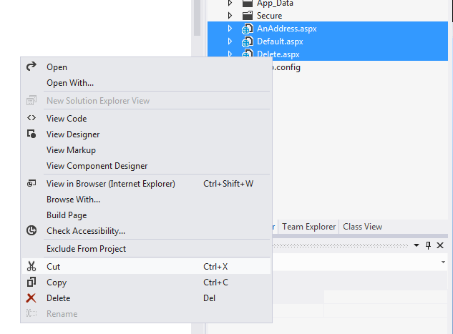

Now paste them into the secure folder.

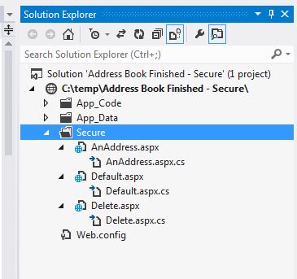

Right click Default.aspx and make sure that it is set as the start page for the web site.

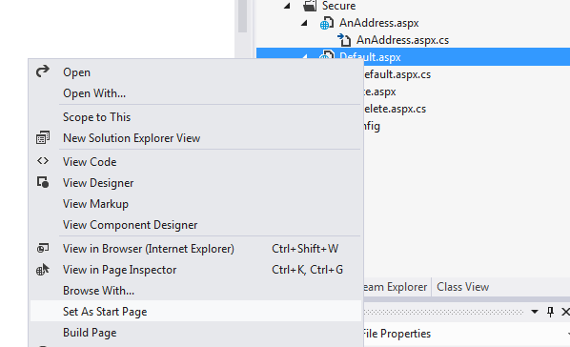

Run the program it should work as it did before the changes.

So far there isn’t much by way of security happening here. We have turned on Forms authentication but nothing else. One problem is that as the system stands everybody has permissions for everything. We shall now change this state of affairs.

Right click on the folder “Secure” and select add new item.

From the list of templates select Web Configuration File....

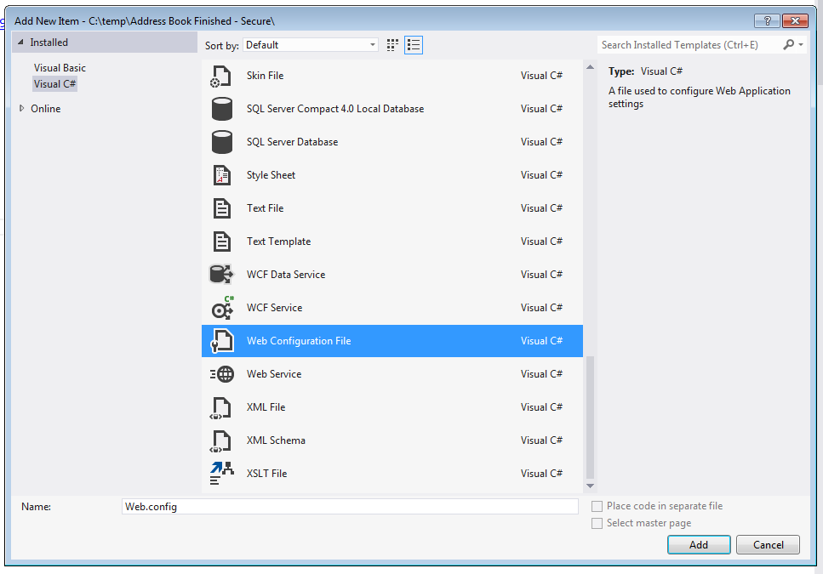

This will create a second Web.config file in the “Secure” folder...

In a .NET web application, it is possible to use multiple Web.config files to control who may access what in each folder.

Edit the new Web.config file like so...

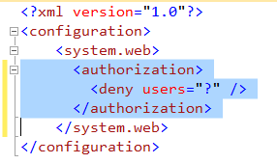

Adding the XML deny users=”?” tells the server to block access to anonymous users.

Run the program and see what happens when we try to view the page Default.aspx in the browser.

You will see the following error...

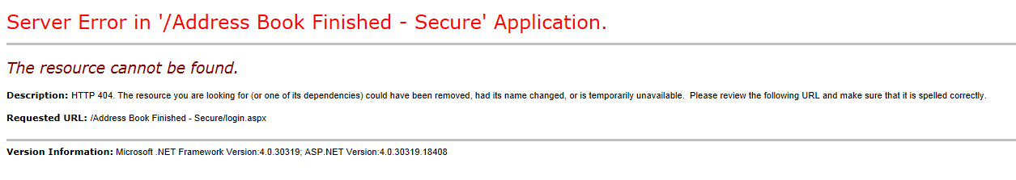
Since we have specified that anonymous users may not access this resource we need to now create a mechanism for authenticating the current user by obtaining a user name and password.

ASP.NET Login Controls

ASP.NET offers a set of controls that allow us to quickly build all the components we need to create an authorisation system.

In the toolbox under the section marked Login you should find the following tools...

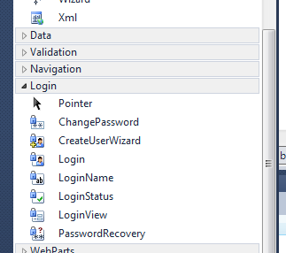

Creating the Login Page

The first page to create is the login page. This page must be called Login.aspx and it must be in the root directory (i.e. not in your Secure folder) of the site like so...

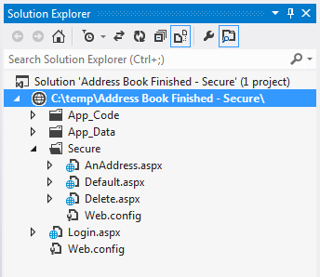

In design view drag and drop the login control onto the page...

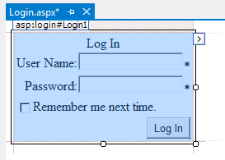

Before we do anything else we will change a couple of the many properties for the control.

In the properties window locate the following properties and change them as shown...

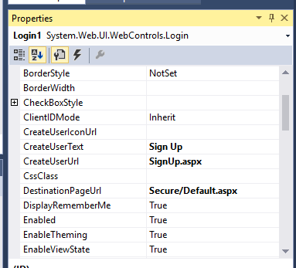

With the page Default.aspx still set as the start up page run the application to see what happens.

We need to test the system to see if everything works.

Possible Error

If you do not get the following error, then skip onto the next section.

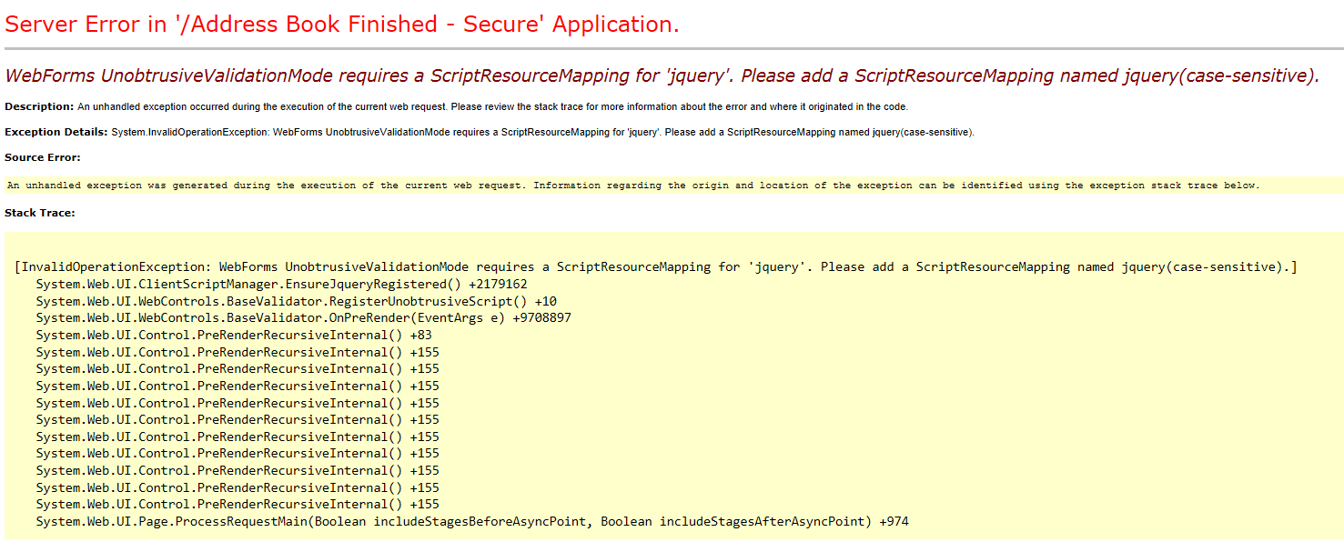
If you do get the above error, then modify the Web.config like so...

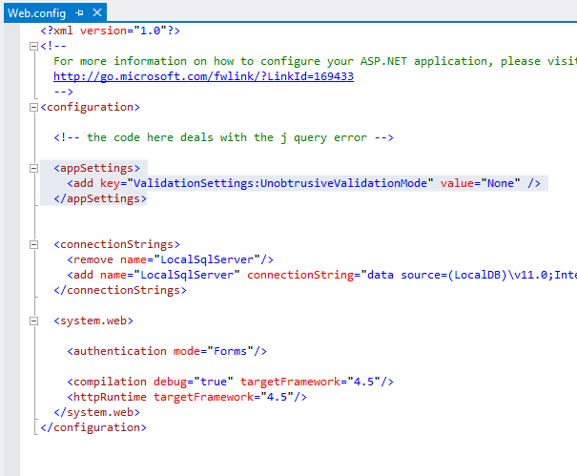

Now try running the application again.

The Next Section

The browser should try to open the page Default.aspx. It should spot from the settings of the Web.config file that anonymous users are not authorised to use this resource. In the light of this it automatically redirects to the page Login.aspx....

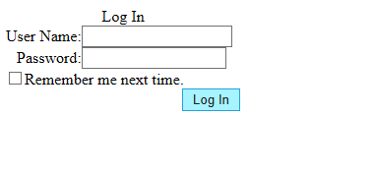
So far if you enter a user name and password you will not be able to sign in as you have not yet created an account. If you try clicking the sign-up link it will fail as we need to create the page SignUp.aspx.

Stop the program and create a new web form in the root directory called SignUp.aspx.

In design view drag and drop the create user wizard...

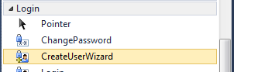

Change the property ContinueDestinationPageUrl to Login.aspx so that the control takes you back to the login page once you have signed up.

Run the program again and this should allow you to create a new user. Once this is completed you should be able to log in and access the page Default.aspx.

There are additional login controls available which are all about as easy to set up as the above. Rather than covering each one I shall let you play with them and explore.

Where is all this Stored?

One very good question is where this user data is being stored for the application?

To store the

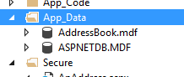

If you inspect the tables you will see how the data is stored.

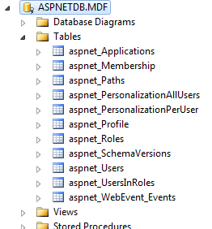

There are three tables of specific interest.

aspnet_Membership

[ApplicationId] UNIQUEIDENTIFIER NOT NULL,
[UserId] UNIQUEIDENTIFIER NOT NULL,
[Password] NVARCHAR (128) NOT NULL,
[PasswordFormat] INT DEFAULT ((0)) NOT NULL,
[PasswordSalt] NVARCHAR (128) NOT NULL,
[MobilePIN] NVARCHAR (16) NULL,
[Email] NVARCHAR (256) NULL,
[LoweredEmail] NVARCHAR (256) NULL,
[PasswordQuestion] NVARCHAR (256) NULL,
[PasswordAnswer] NVARCHAR (128) NULL,
[IsApproved] BIT NOT NULL,
[IsLockedOut] BIT NOT NULL,
[CreateDate] DATETIME NOT NULL,
[LastLoginDate] DATETIME NOT NULL,
[LastPasswordChangedDate] DATETIME NOT NULL,
[LastLockoutDate] DATETIME NOT NULL,
[FailedPasswordAttemptCount] INT NOT NULL,
[FailedPasswordAttemptWindowStart] DATETIME NOT NULL,
[FailedPasswordAnswerAttemptCount] INT NOT NULL,
[FailedPasswordAnswerAttemptWindowStart] DATETIME NOT NULL,
[Comment] NTEXT NULL,
PRIMARY KEY NONCLUSTERED ([UserId] ASC),
FOREIGN KEY ([ApplicationId]) REFERENCES [dbo].[aspnet_Applications] ([ApplicationId]),
FOREIGN KEY ([UserId]) REFERENCES [dbo].[aspnet_Users] ([UserId])

aspnet_Roles

[ApplicationId] UNIQUEIDENTIFIER NOT NULL,
[RoleId] UNIQUEIDENTIFIER DEFAULT (newid()) NOT NULL,
[RoleName] NVARCHAR (256) NOT NULL,
[LoweredRoleName] NVARCHAR (256) NOT NULL,
[Description] NVARCHAR (256) NULL,
PRIMARY KEY NONCLUSTERED ([RoleId] ASC),
FOREIGN KEY ([ApplicationId]) REFERENCES [dbo].[aspnet_Applications] ([ApplicationId])

aspnet_UsersInRoles

[UserId] UNIQUEIDENTIFIER NOT NULL,
[RoleId] UNIQUEIDENTIFIER NOT NULL,
PRIMARY KEY CLUSTERED ([UserId] ASC, [RoleId] ASC),
FOREIGN KEY ([UserId]) REFERENCES [dbo].[aspnet_Users] ([UserId]),
FOREIGN KEY ([RoleId]) REFERENCES [dbo].[aspnet_Roles] ([RoleId])

These tables relate to each other like so…

Membership

UsersInRoles

Roles

To create a new role, we will need to add it to the table aspnet_UsersInRoles.

You will need to first make a note of the application ID for this application which is found in aspnet_Applications

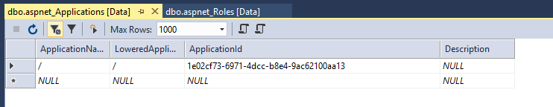

We won’t cover this here but there are facilities to create accounts that are specific to individual projects within the solution.

Make a note of the application ID in this case

1e02cf73-6971-4dcc-b8e4-9ac62100aa13

Now using this ID create the new role “admin” in aspnet_Roles table

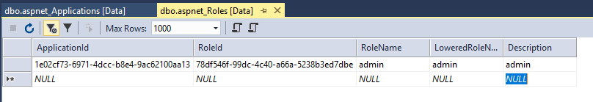

The role ID will be automatically generated by the table for you when you add the new role.

Once you have created the role you may now allocate users to the role by adding entries in the table aspnet_UsersInRole

For this you will neeed the role ID, in this case
78df546f-99dc-4c40-a66a-5238b3ed7dbe
Also the user ID, in this case
80269271-9c2c-4593-b4b6-0089c14a7247

Using the two values we can allocate a user to a role like so…

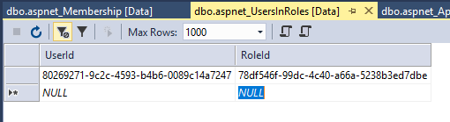

Establishing Identity and Roles in our Code

Once we have set up user accounts and roles it would be useful to identify specific users in a page so that we may control what that user has access to.

The first step is to make sure that roles are turned on in the web config file. Add the following line to the Web.config in the root folder…

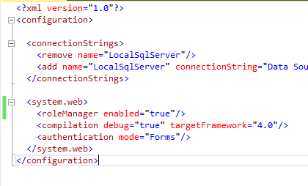

Now modify the page Defaut.aspx to include a label called lblUserInfo like so...

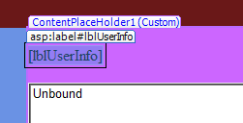

Now modify the load event using the following code...

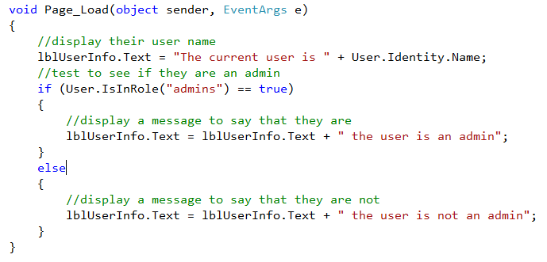

The User object allows us to inspect various aspects of the currently authenticated user to find out their authentication status, their name and which roles they are in.

Handling Authorisation

We are now able to authenticate our users to make sure they are who they say they are. We are now able to handle authorisation to control what they have access to.

Let’s assume that in our system all users have the right to add and edit records, however only admin users can delete records.

A very simple way of handling this would be to manipulate the visible property for any controls.

Look at the following code…

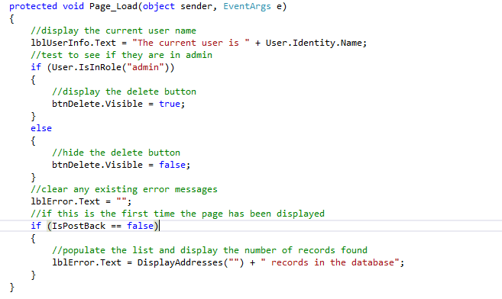

You will need two users to test this, one who is admin and a second one who is not.

When the admin user logs in they will have access to the delete button and the non admin will not.

Controlling Access to Specific Data

A slightly more complicated approach to authorisation requires modifying the design of the system to consider who the current user is and only show data that belongs to them. We will look at a partial solution to this and then outline how it would need to be extended.

When the application loads the list-box is being populated from the database like so…

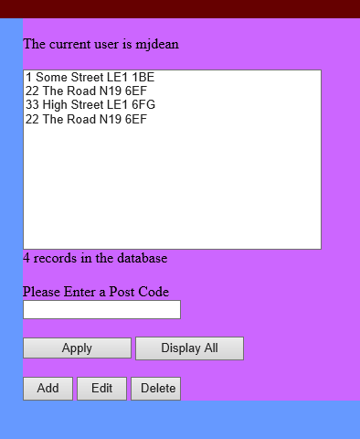

This data is being drawn from the table tblAddress…

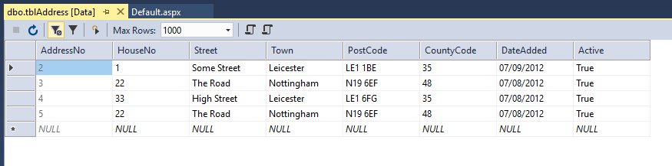

The first step is to create a new field in the table called UserName like so…

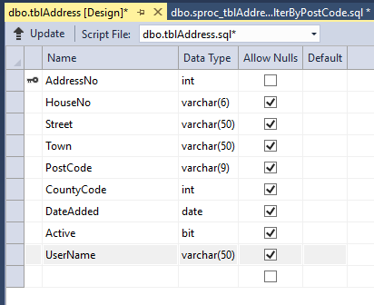

You will need to now allocate some records to one user and others to a second user…

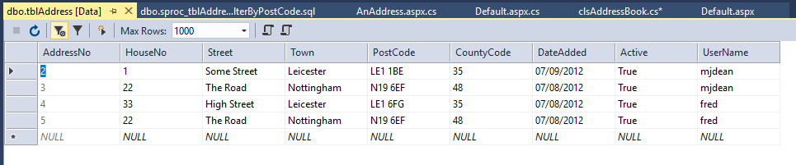

We are now going to have to make some changes to the structure of all layers of the system.

The first step is to modify the middle layer such that it knows who the current user is when any objects are instantiated.

The simplest way to do this is to create a constructor that accepts a parameter identifying the current user.

For this example we will modify the collection class (clsAddressBook).

Add the constructor like so…

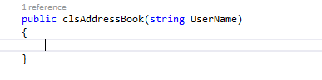
This will create a problem in that the program no longer compiles. Try it and see.

Whenever you create an instance of this class you must now prived the name of the current user.

Work through the errors to fix the problem along the following lines…

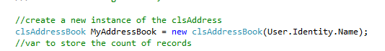

Once the errors are fixed you will need to create a private member variable to store the user name within the class…

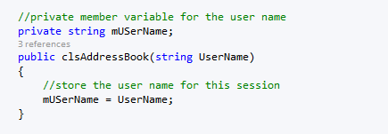

When a user logs in the middle layer now knows who they are.

The next step is to make use of this data in the data layer.

Open the stored procedure sproc_tblAddress_FilterByPostCode

Modify the code like so…

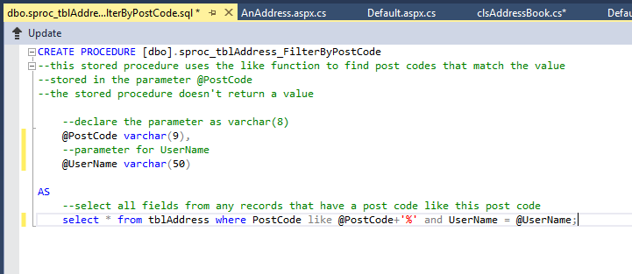

In the middle layer you will need to add the additional parameter on any code using this stored procedure like so…

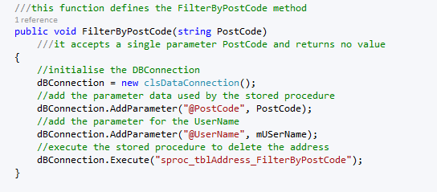

If everything is configured correctly then the list should now only display the records belonging to the currently logged in user like so…

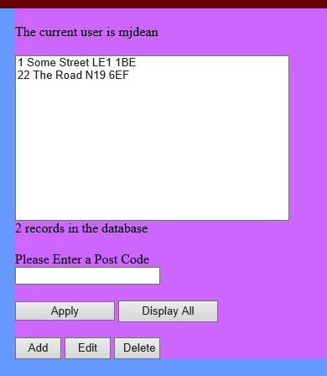

To complete this functionality you will need to modify the insert stored procedure for the table so that it includes the user name like so…

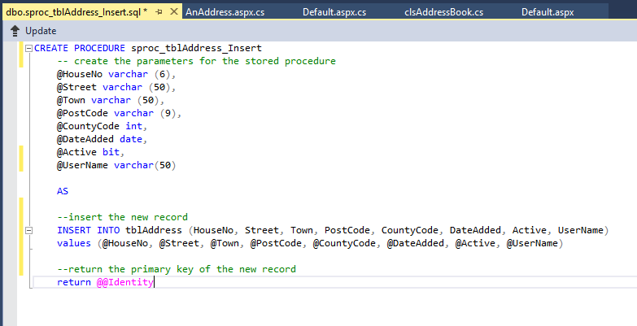

Finally modify the middle layer such that the user name is included with any new records added to the table

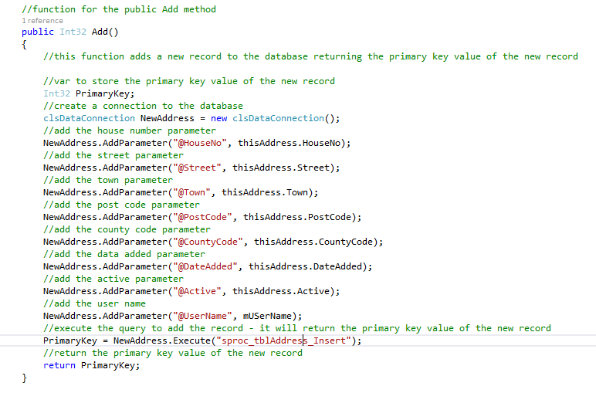

From now on when the current user adds a record to the table it will be stamped with their user name and only they will be able to see the data.

